**TABLE (FROM 2011-2014 NICOR report data)**

|  |  |  |  |  |  |
| --- | --- | --- | --- | --- | --- |
| Hospital **(CAN SORT ON THIS)** | Hospital Code | Number of Operations **(CAN SORT ON THIS)** | Number of deaths | Number of survivors | Observed Survival rate (%) |
| Belfast, Royal Victoria Hospital | RVB | 204 | 2 | 202 | 99.0% |
| London, Harley Street Clinic | HSC | 482 | 7 | 475 | 98.5% |
| Leicester, Glenfield Hospital | GRL | 582 | 11 | 571 | 98.1% |
| Newcastle, Freeman Hospital | FRE | 678 | 15 | 663 | 97.8% |
| Glasgow, Royal Hospital for Children | RHS | 787 | 28 | 759 | 96.4% |
| Bristol Royal Hospital for Children | BRC | 835 | 19 | 816 | 97.7% |
| Southampton, Wessex Cardiothoracic Centre | SGH | 890 | 17 | 873 | 98.1% |
| Leeds General Infirmary | LGI | 976 | 23 | 953 | 97.6% |
| Dublin, Our Lady's Children's Hospital | OLS | 1056 | 23 | 1033 | 97.8% |
| London, Royal Brompton Hospital | NHB | 1107 | 12 | 1095 | 98.9% |
| Liverpool, Alder Hey Hospital | ACH | 1146 | 28 | 1118 | 97.6% |
| London, Evelina London Children's Hospital | GUY | 1204 | 39 | 1165 | 96.8% |
| Birmingham Children’s Hospital | BCH | 1481 | 30 | 1451 | 98.0% |
| London, Great Ormond Street Hospital for Children | GOS | 1881 | 30 | 1851 | 98.4% |

**NEXT TO FINAL COLUMN HAVE CHART AS DISCUSSED (ie horizontal dots & ranges. Use two ranges. Have a morph/slider to change survival axis scale from 0 to min lower range (or 92% if easier?).**

**Column explanations…**

* **Hospital Code**: abbreviation for the hospital
* **Hospital**: name of the hospital *[provide map with this]*
* **Number of operations\***: the number of heart operations carried out on under-16s at each hospital during the 3 years April 2011 to March 2014 *[ link * : operations on the same child that occur within 30 days of each other are treated as a single operation and the death or survival of the child 30 days after the 1st operations is included in the analysis.]*
* **Number of deaths**: the number of operations where the child died within 30 days of their operation, from any cause
* **Number of survivors**: the number of operations where the child survived at least 30 days after their operation
* **Survival rate**: the percentage of operations where the child survived at least 30 days after their operation
* **Meaning of dot**: a dot represents the observed survival rate in each hospital.
* **Blue band - interpreting a dot for a *single* unit**.
* **Light blue band:** A dot in this area means that there is no evidence that the hospital’s survival rate is meaningfully different from what is predicted*. [link to terminology in FAQ]*.
* **Dark blue band:** A dot within the right hand dark blue band means that there is some evidence that chances of survival in the hospital were higher than predicted. *[link to FAQ]*.A dot within the left hand dark blue band means that there is some evidence that chances of survival in the hospital were lower than predicted. *[link to FAQ]*.
* **Dot outside the bands:** A dot to the right of the bands means that there is strong evidence that chances of survival in the hospital were higher than predicted. *[link to FAQ]*.A dot to the left of the bands means that there is strong evidence that chances of survival in the hospital were lower than predicted. *[link to FAQ]*.

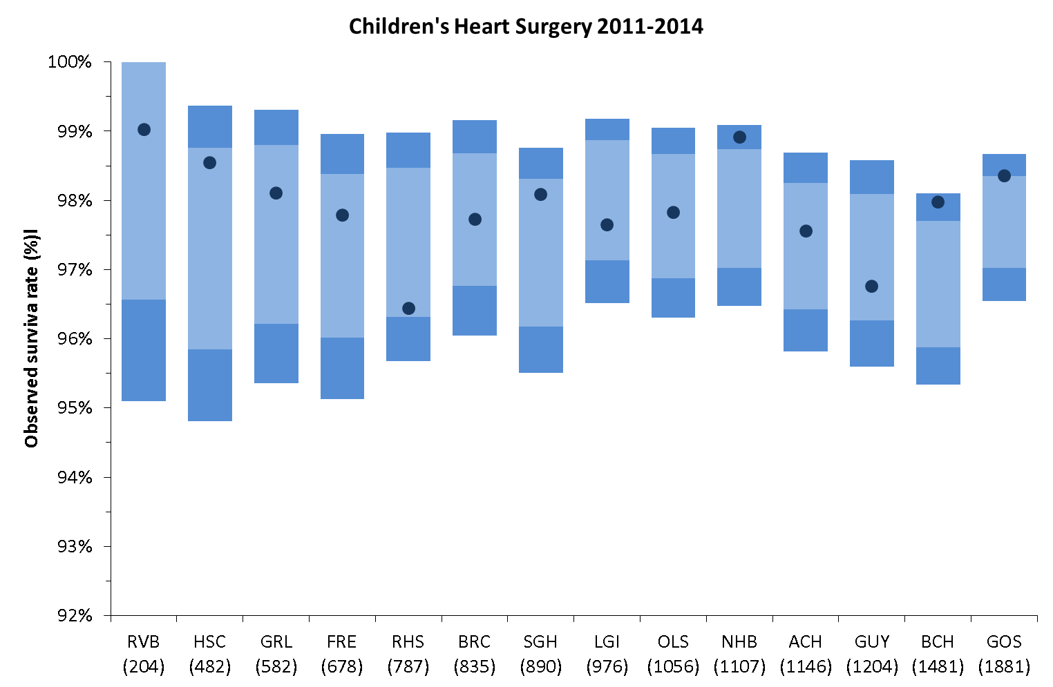

**INTERPRETATION:**

Based on the data above, there is no evidence to suggest that patients at any hospital have a lower chance of survival than predicted. There is some, but not strong, evidence that a patient’s chances of survival at Dublin and Birmingham hospitals are higher than predicted.